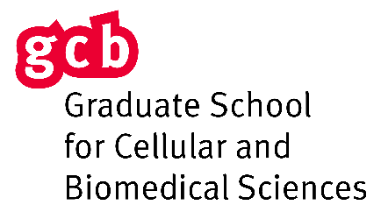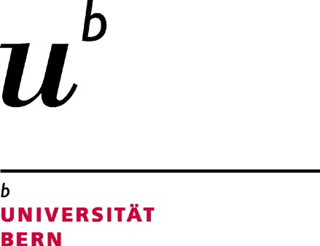

Registration for the PhD specialization program “Stem Cells and Regenerative Medicine”

- Personal Data

Last Name |  | First Name
Supervisor |  | E-mail
Co-Advisor |  | E-mail
Mentor |  | E-mail
Starting date of PhD Studies |  | Matriculation No.
Thesis Title
Institute
Office Address
Zip Code |  | City
Phone |  | Mobile
Correspondence E-mail
The PhD Program Stem Cells and Regenerative Medicine (SCRM) cooperates with the Graduate School for Cellular and Biomedical Sciences of the University of Berm (GCB). Students enrolled in the PhD program SCRM earn 6 ECTS to graduate from the GCB and to fulfill the requirements of the PhD Program SCRM. After registration, you will receive a form where course work for “Stem Cells and Regenerative Medicine” can be listed.

Students who have are already completed the GCB doctoral agreement, will receive a personalized form to adapt it to the SCRM specialization requirements. The certificate of the PhD Program Stem Cells and Regenerative Medicine will be issued after graduation from the GCB and is valid only in combination with the GCB of the University of Bern graduation certificates.
- Signatures PhD Student
☐ | With my signature, I agree on the exchange of personal data between GCB and the PhD program Stem  Cells and Regenerative Medicine (SCRM).
Place, Date |  |  | Signature

Supervisor and Mentor

Supervisor Signature |  | Mentor Signature
Place, Date |  | Place, Date
Please send to Volker Enzmann, volker.enzmann@insel.ch, with cc to Monica Schaller, info.gcb@.unib.ch.
Form_ September 2021

